**Registration methods**

When we scan a place we have the following options for auto registration:

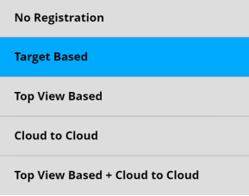

No registration – Here we do everything manually.

Target Based – we have targets such as checkerboards or spheres. Targets should be located uniqually and they cannot be alligned. Targtes should be placed such that the angle when you look at them has to be greater than 45 degrees (90 degrees is perfect the minimum is 45 degrees). Targets are automatically selected by the Scene software (our software can differentiate the colors of the squares of the checkerboards).

Top View Based- this aligns scans based on the top view.

Cloud to Cloud- we make the registration with the help of overlaps.

For auto registration, we have to turn on the altimeter, inclinometer, gps, and compass.

Also we can use none of the methods shown above. We can create the point cloud via only the devices. But here there could be errors due to magnetic field which can cause minor errors in gps, or slight change on the surface can result in a difference in the inclination of the tripod, leading to major errors.

Also we need to close windows or mirrors if there are any so that they are not empty.